Business Question and Visualization Report

Question 1: What are the key performance indicators of the food ordering business?
- Visualization: A KPI Dashboard summarizes the overall performance of the food ordering business

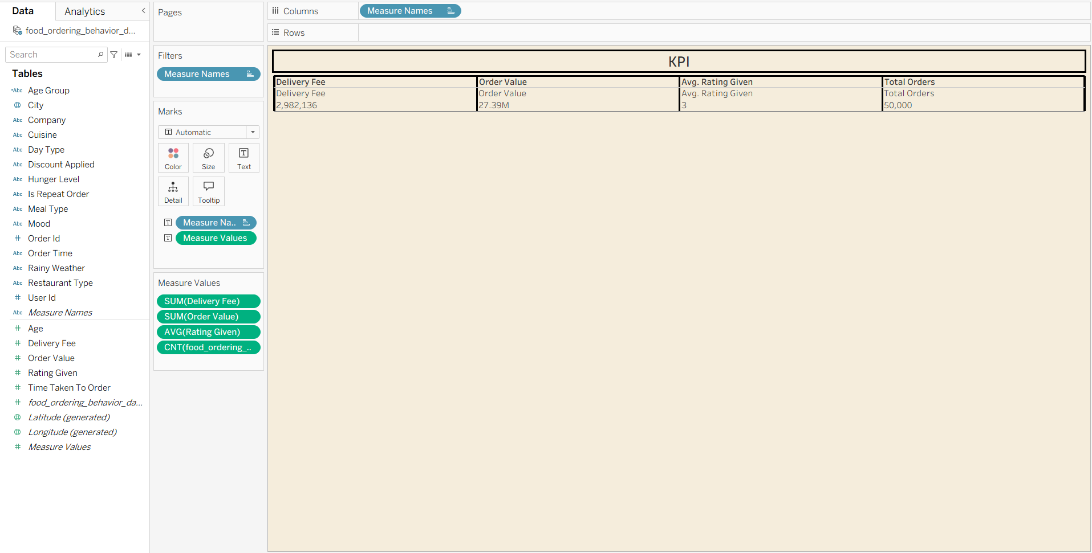

Question 2: Which cuisine generates the highest total order value?
- Visualization: Visualization: Horizontal Bar Chart highlighting cuisine segments (North Indian, Chinese, Italian, Fast Food).
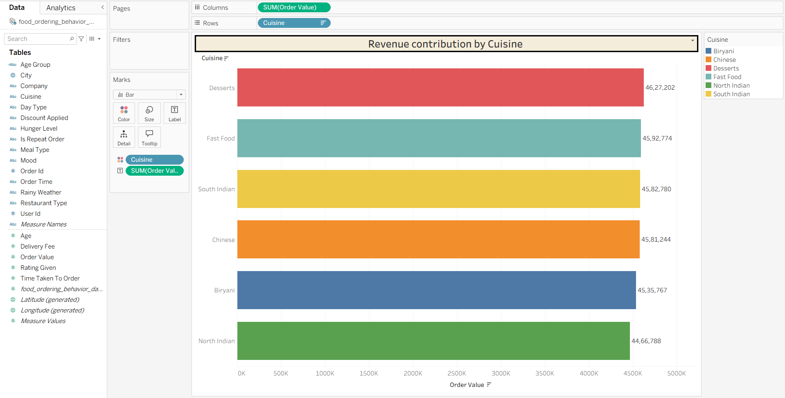
Question 3: What percentage of total revenue comes from each meal type?
- Visualization: A pie chart representing total revenue from meal type (Breakfast, Lunch, Evening Snacks, Dinner).
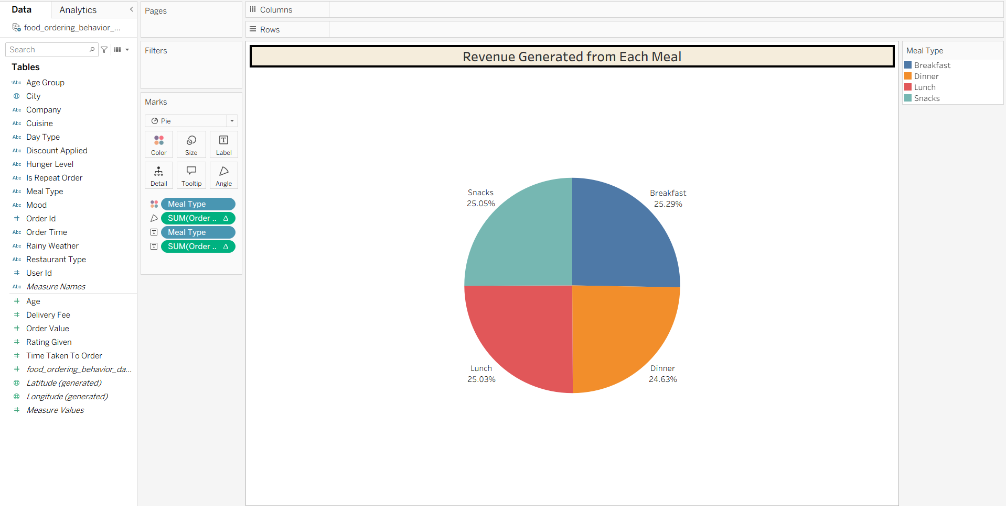

Question 4: Which company contributes the highest number of total order value?
- Visualization: A Donut Chart highlighting the total order value (Alone, family, friends, partner)
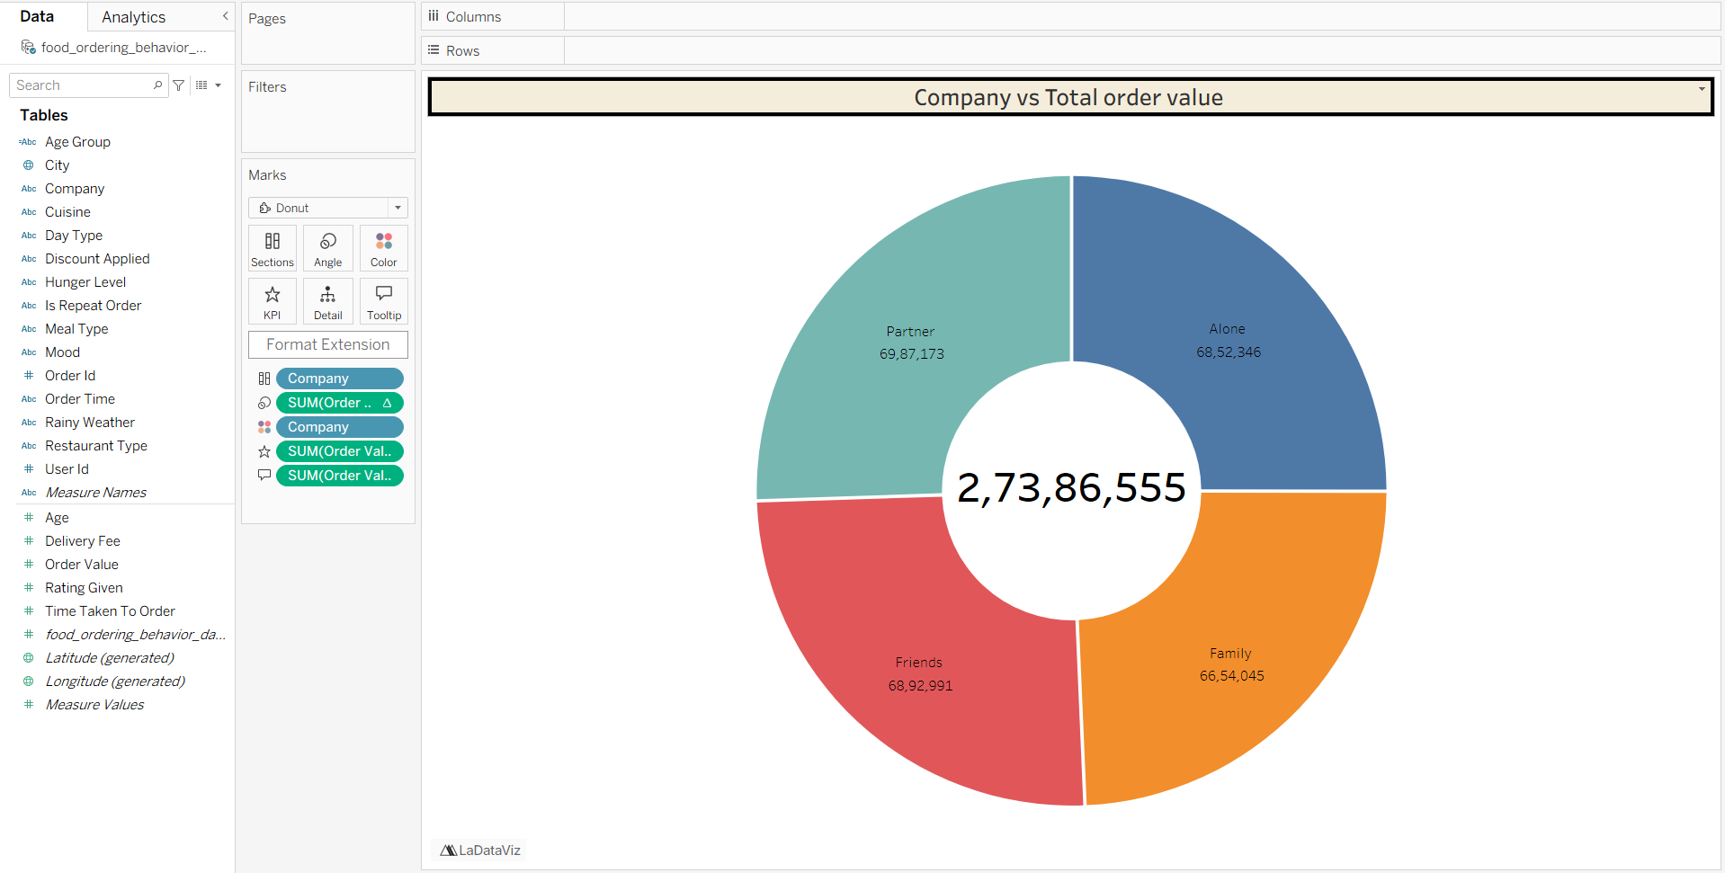

Question 5: Which city has the highest average order delivery time?
- Visualization: A Line Chart showing Average time taken to order
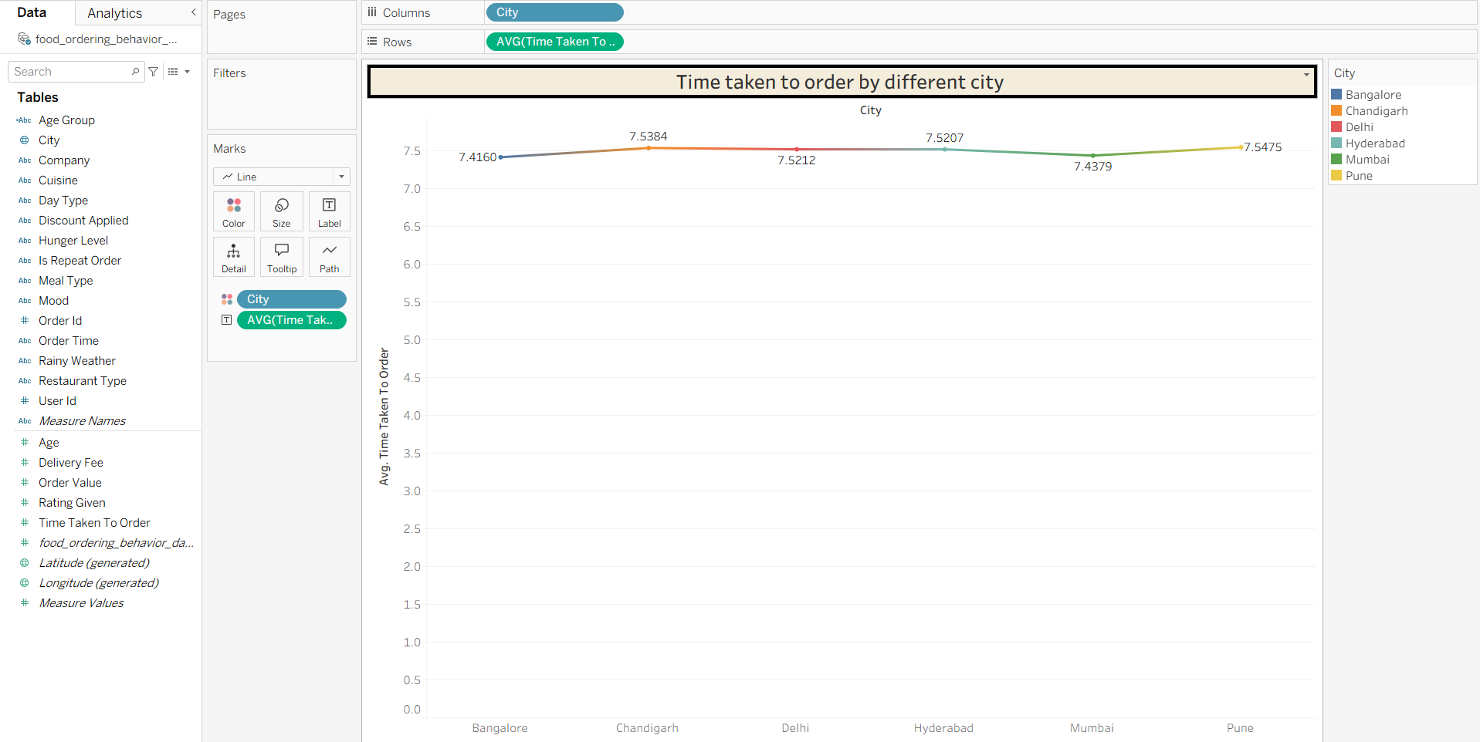

Question 6: Which meal type is popular in each city?
- Visualization: A grouped Bar Chart compares the preferences across different cities and identify which meal type is most frequently ordered in each city.
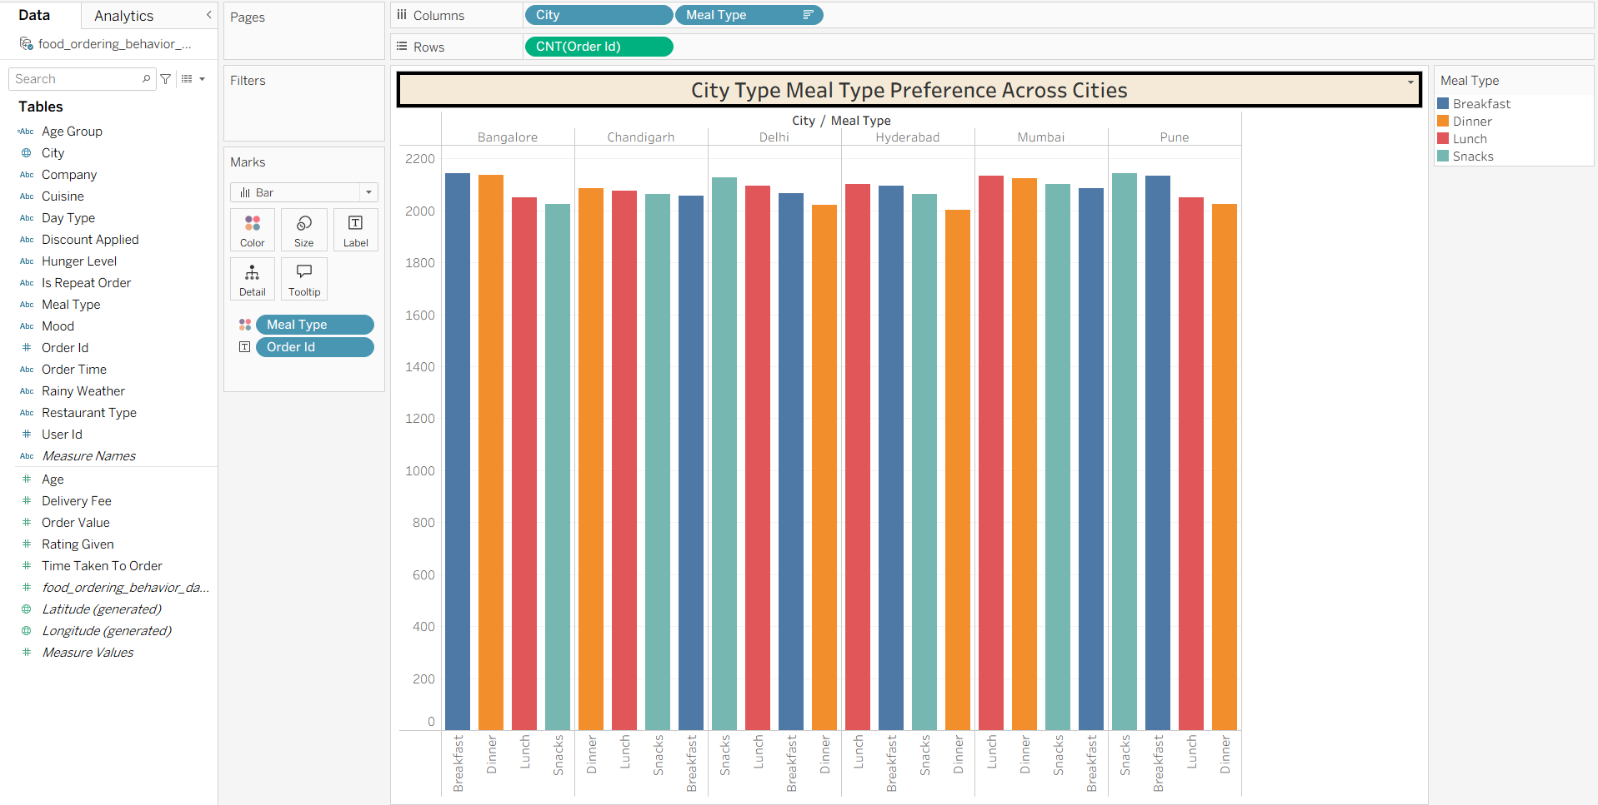
Question 7: Which Restaurant types generate the highest revenue across different cuisines?
- Visualization: A Treemap compares the revenue generated by different cuisines within each restaurant type.
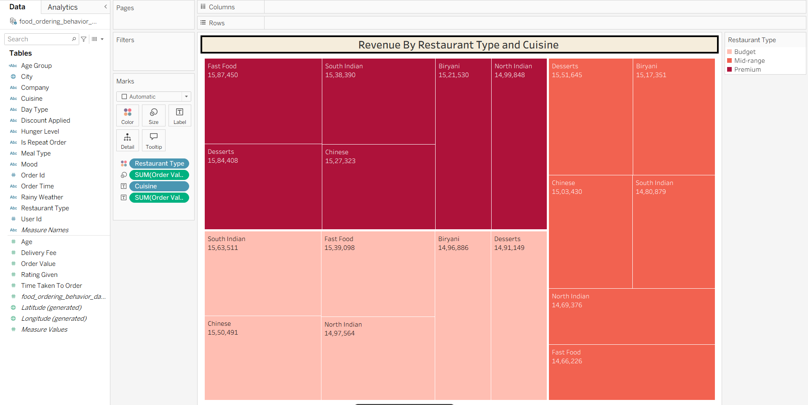
Question 8: Which Age group spends the highest amount on food orders?
- Visualization: A packed bubble chart highlighting total order value by each age group
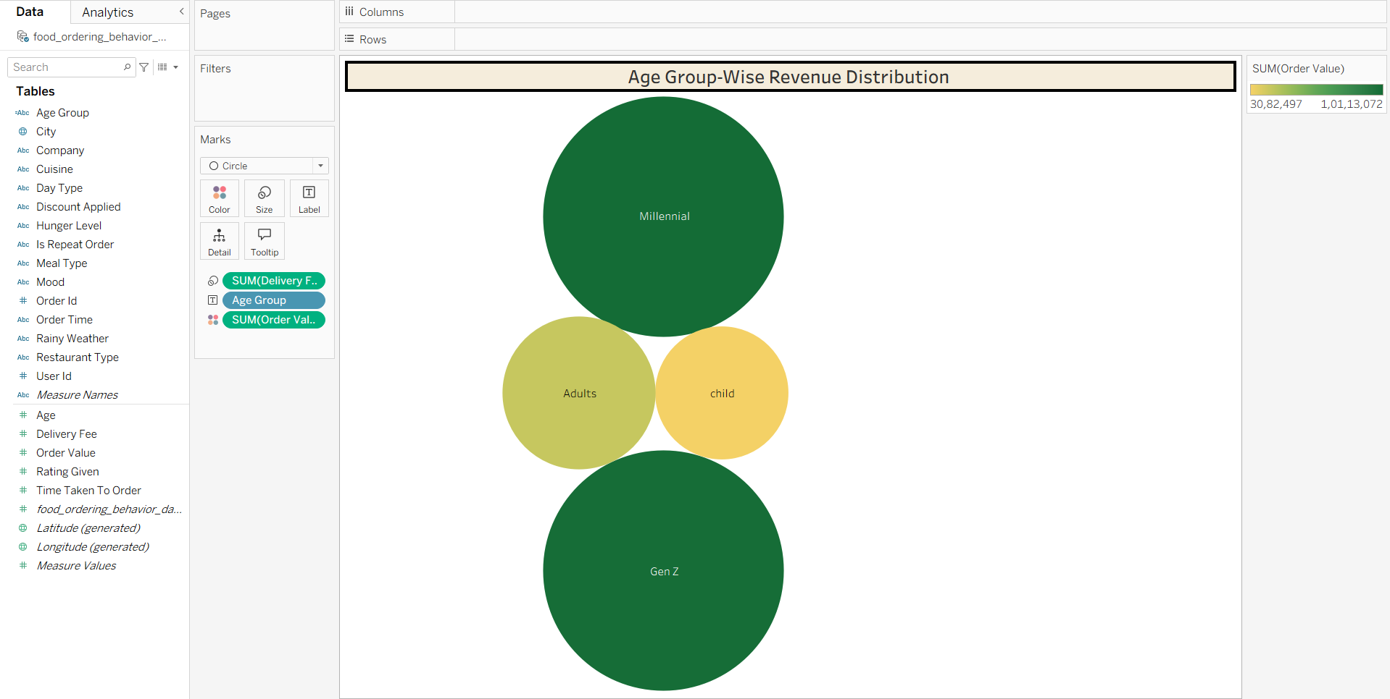
Question 9: how does weather affect the average order value across different cities?
- Visualization: A heat map is used to compare the average order value across different cities under rainy and non rainy weather conditions.
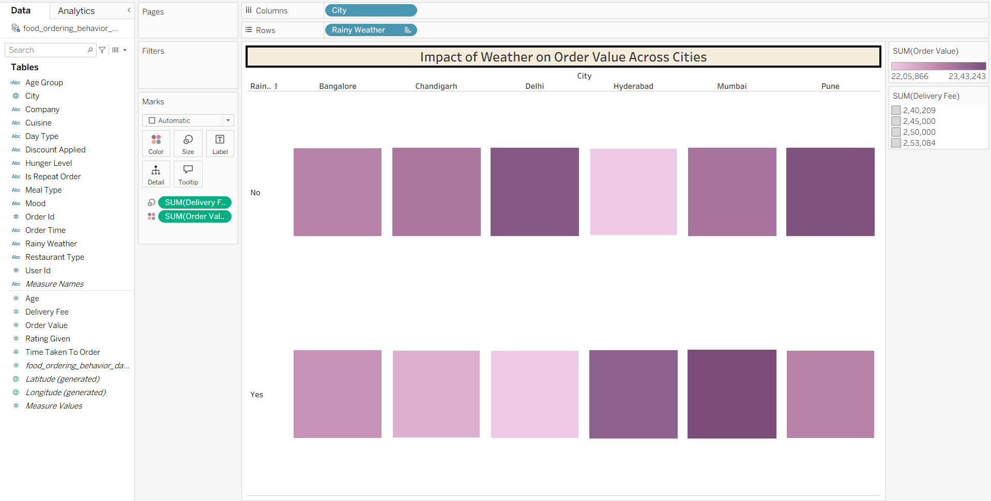
Question 10: Which cuisine receives the highest ratings?
- Visualization: A stacked bar chart

